Team Task Management System — Build Plan & Prompts
Sep 28, 2026 · @Sulthan Sha

Overview and stack
Build V1 as a TypeScript monorepo: React + Vite frontend, Node + Express API, PostgreSQL 16, with a Postgres-backed job queue so you don't need Redis on day one. The original plan's modules stay; this plan adds a stricter data model, a server-enforced status workflow, and features that make the Team Lead view trustworthy (last-activity tracking, leave-aware workload, member check-ins).
Layer | Choice | Why
Monorepo | pnpm workspaces: apps/web, apps/api, packages/shared | One place for types, Zod schemas and enums used by both sides
Frontend | React + Vite + TypeScript, React Router, TanStack Query | Server-state caching, optimistic updates for Kanban drags
UI | Tailwind + shadcn/ui, dnd-kit (Kanban), Recharts (reports) | Fast to build, accessible, easy to theme
Forms | React Hook Form + Zod (schemas from packages/shared) | Same validation on client and server
Backend | Node LTS + Express + TypeScript | Matches your existing skills
Database | PostgreSQL 16 | Enums, JSONB, timestamptz, full-text search, partial indexes
DB access | Drizzle ORM + drizzle-kit migrations | SQL-first, typed, close to raw SQL you already know
Auth | Short-lived JWT access token + rotating refresh token in HTTP-only cookie, argon2 hashes | Revocable sessions, no tokens in localStorage
Realtime | Socket.IO (rooms per user and per project) | Live Kanban, live notifications
Background jobs | pg-boss (queue inside Postgres) | Alerts, digests, recurring tasks with no Redis; move to BullMQ + Redis only if you outgrow it
Files | Local disk in dev, S3-compatible (MinIO) in prod, presigned URLs | Same code path in both
Email | Nodemailer + SMTP, React Email templates | Digest and alert emails
Logging and tests | pino, Vitest + Supertest, Playwright, Testcontainers for Postgres | Real Postgres in tests, not mocks
Deploy | Docker Compose + Nginx, GitHub Actions CI | Single VPS is enough for a team of 8–30
AI stays out of V1, as in the original plan; the activity and time data V1 collects is what makes V2 AI useful.

What to add beyond the original plan
The original plan covers the core well. These additions close the gaps that usually make a Team Lead stop trusting the dashboard: stale data, unclear blockers, and workload that ignores leave.
Feature | What it does | Why it matters | Phase
Project task keys | Tasks numbered per project: ERP-125, CRM-18 | Readable IDs people say out loud and put in commit messages | 1
Server-enforced workflow | Status changes validated by a state machine with role rules; CANCELLED status and lead-only reopen | Nobody jumps a task from Assigned to Completed; review can't be skipped | 1
Reviewer field | Each task has an assignee and an optional reviewer | Review queue routes to the right person, not always you | 1
Blocker details | Reason required, blocker type (dependency, external, waiting on client, waiting on person), blocked-since time | "Blocked" becomes actionable; you see how long and on whom | 1
last_activity_at on every task | Updated on any status, progress, comment or time log | Powers the "no update in 28 hours" alert cheaply | 1
@mentions and watchers | @Rahul in a comment notifies him; anyone can follow a task | Conversations stay on the task, not in WhatsApp | 2
Checklists / acceptance criteria | Checklist items on a task; optional auto-progress from checked items | Progress % reflects real work instead of a guess | 3
Time tracking | Start/stop timer or manual log per task | Estimate vs actual per person and per label; better future estimates | 3
Leave and holidays | Members mark leave; org sets weekend days and public holidays | Workload and overdue math respect who is actually available | 3
Capacity-based workload | Remaining estimated hours ÷ available hours in the next 5 working days | "6 small tasks" and "2 huge tasks" stop looking the same | 3
Async member check-in | Each member posts yesterday / today / blockers by 10:00 | Your morning digest combines system data with what people say | 3
Handover on reassign | Reassigning requires a handover note; old assignee stays as watcher | No lost context when someone goes on leave | 2
Saved views and bulk actions | Save filters ("Overdue high priority"), bulk reassign/re-prioritise | Faster weekly planning | 3
Global search + Ctrl+K | Postgres full-text search across tasks and comments | Find anything by keyword or task key | 3
Task and project templates | Reusable task sets (e.g. "New client onboarding") | Repeatable work set up in one click | 3
Reports | On-time rate, cycle time, throughput, overdue trend, estimate accuracy; CSV/Excel export | Evidence for planning, not a performance score | 3
Escalation rules | Configurable: overdue by 2 working days → notify lead again; blocked > 24 h → escalate | Alerts that follow up without you remembering | 2
Notification preferences + quiet hours | Per-type channel choice, digest mode, no pings after hours | Prevents alert fatigue, which kills adoption | 2
Git integration | Link commits/PRs by task key; PR opened → Ready for Review; merged → Completed on approval | Status updates happen automatically for dev work | 4
WhatsApp / Slack / Teams | Alerts and digest to chat; reply-to-comment later | Meets the team where they already are | 4
PWA + web push | Installable on phones, push notifications | Members update from mobile without an app store build | 4
Audit and backups | Admin audit log, nightly pg_dump to S3, restore test | You can answer "who changed this" and survive a bad day | 1–5
Keep one principle from the original plan throughout: members see the same facts about themselves that the lead sees, and the system shows evidence rather than scoring people.

Architecture and repo structure
One codebase, two processes: the HTTP server and a background worker, both talking to one Postgres database.
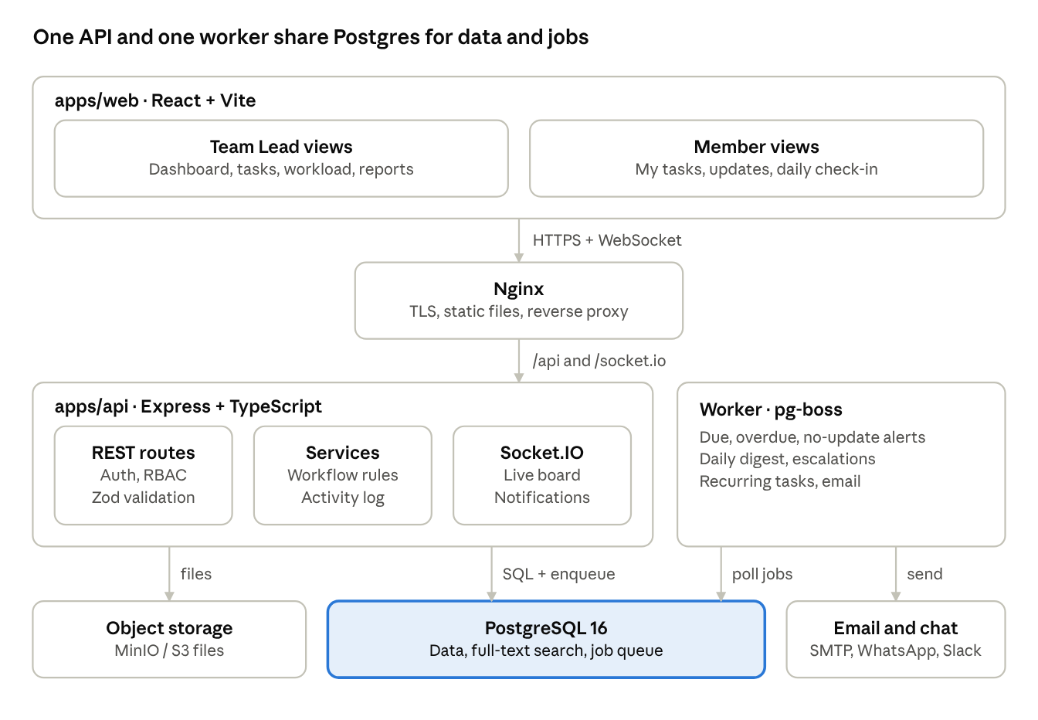
system architecture · web, API, worker, data
The worker is the same apps/api code started from worker.ts, so alerts and digests reuse the same services and rules as the API. Workflow transitions live in packages/shared, so the UI only shows buttons the server will accept.
task-manager/
├─ apps/
│ ├─ api/
│ │ ├─ src/
│ │ │ ├─ config/ env parsing with zod
│ │ │ ├─ db/ drizzle schema, migrations, seed
│ │ │ ├─ modules/ one folder per domain
│ │ │ │ ├─ auth/ users/ teams/ projects/
│ │ │ │ ├─ tasks/ routes, service, workflow.ts
│ │ │ │ ├─ comments/ attachments/ notifications/
│ │ │ │ └─ dashboard/ workload/ reports/ checkins/
│ │ │ ├─ jobs/ pg-boss handlers
│ │ │ ├─ realtime/ socket.io gateway
│ │ │ ├─ middleware/ auth, rbac, errors, rate limit
│ │ │ ├─ server.ts HTTP entry
│ │ │ └─ worker.ts job worker entry
│ │ └─ test/
│ └─ web/
│ └─ src/
│ ├─ app/ router, providers, layout
│ ├─ features/ dashboard, tasks, board, calendar, team, reports
│ ├─ components/ui/ shadcn components
│ ├─ lib/ api client, socket, query keys
│ └─ hooks/
├─ packages/
│ └─ shared/ zod schemas, enums, workflow, types
├─ docker/ Dockerfiles, nginx.conf
├─ docker-compose.yml
└─ CLAUDE.md project rules for your AI coding tool

PostgreSQL schema
The schema keeps your original tables and adds teams, labels, watchers, checklists, time logs, leave, check-ins, sessions and alert de-duplication. All timestamps are timestamptz stored in UTC; date logic (due today, overdue) uses the org time zone.
-- Enums
CREATE TYPE user_role AS ENUM ('SUPER_ADMIN','TEAM_LEAD','MEMBER');
CREATE TYPE task_status AS ENUM ('BACKLOG','ASSIGNED','IN_PROGRESS','BLOCKED','READY_FOR_REVIEW',
'IN_REVIEW','CHANGES_REQUESTED','COMPLETED','CANCELLED');
CREATE TYPE task_priority AS ENUM ('LOW','MEDIUM','HIGH','URGENT');
CREATE TYPE blocker_type AS ENUM ('DEPENDENCY','EXTERNAL','WAITING_ON_CLIENT','WAITING_ON_PERSON','OTHER');
-- People and structure
users (id uuid PK, name, email citext UNIQUE, password_hash, role user_role,
timezone text DEFAULT 'Asia/Kolkata', avatar_url, is_active bool,
last_login_at, created_at, updated_at)
sessions (id uuid PK, user_id FK, refresh_token_hash, user_agent, ip,
expires_at, revoked_at, created_at)
teams (id uuid PK, name, lead_id FK users, created_at)
team_members (team_id FK, user_id FK, joined_at, PRIMARY KEY (team_id, user_id))
projects (id uuid PK, key varchar(10) UNIQUE, -- 'ERP'
name, description, status, team_id FK,
task_counter int DEFAULT 0, -- next task number
created_by FK, created_at, archived_at)
-- Tasks
tasks (id uuid PK, project_id FK, number int, -- ERP-125 = key + number
title, description text, -- markdown
status task_status, priority task_priority,
created_by FK, assignee_id FK NULL, reviewer_id FK NULL,
parent_task_id FK tasks NULL,
progress smallint CHECK (progress BETWEEN 0 AND 100),
start_date date, due_date date, estimated_minutes int,
blocked_reason text, blocker_type blocker_type, blocked_at timestamptz,
last_activity_at timestamptz, -- drives no-update alerts
completed_at, recurring_rule_id FK NULL,
search tsvector GENERATED ALWAYS AS (
to_tsvector('simple', coalesce(title,'') || ' ' || coalesce(description,''))) STORED,
created_at, updated_at, deleted_at,
UNIQUE (project_id, number))
CREATE INDEX ON tasks (assignee_id, status) WHERE deleted_at IS NULL;
CREATE INDEX ON tasks (due_date) WHERE status NOT IN ('COMPLETED','CANCELLED');
CREATE INDEX ON tasks USING gin (search);
labels (id PK, project_id FK NULL, name, color)
task_labels (task_id FK, label_id FK, PRIMARY KEY (task_id, label_id))
task_watchers (task_id FK, user_id FK, PRIMARY KEY (task_id, user_id))
task_dependencies (task_id FK, depends_on_task_id FK, type text DEFAULT 'BLOCKS',
CHECK (task_id <> depends_on_task_id))
checklist_items (id PK, task_id FK, text, is_done bool, position int, done_by FK, done_at)
-- Collaboration and history
task_comments (id PK, task_id FK, user_id FK, body text, edited_at, deleted_at, created_at)
comment_mentions (comment_id FK, user_id FK)
task_attachments (id PK, task_id FK, uploaded_by FK, file_name, mime_type,
size_bytes, storage_key, created_at)
task_activity (id bigserial PK, task_id FK, actor_id FK, action text,
field text, old_value jsonb, new_value jsonb, meta jsonb, created_at)
CREATE INDEX ON task_activity (task_id, created_at);
-- Time, availability, check-ins
time_logs (id PK, task_id FK, user_id FK, started_at, ended_at, minutes int, note)
leaves (id PK, user_id FK, start_date, end_date, type, note, created_at)
holidays (date PK, name)
org_settings (id PK, timezone, weekend_days int[], work_hours_per_day numeric,
no_update_threshold_hours int, digest_time time)
daily_checkins (id PK, user_id FK, date, yesterday, today, blockers, created_at,
UNIQUE (user_id, date))
-- Automation and notifications
recurring_rules (id PK, project_id FK, template jsonb, rrule text, timezone,
assignee_id FK, next_run_at, is_active)
notifications (id PK, user_id FK, task_id FK NULL, type, title, body,
data jsonb, read_at, created_at)
notification_preferences (user_id FK, type, in_app bool, email bool,
whatsapp bool, digest_only bool, PRIMARY KEY (user_id, type))
alert_log (task_id FK, alert_type, sent_on date, PRIMARY KEY (task_id, alert_type, sent_on))
saved_views (id PK, user_id FK, name, view_type, filters jsonb, is_shared bool)
Two rules keep the data honest. Every change to a task writes a task_activity row in the same transaction. Task numbers come from UPDATE projects SET task_counter = task_counter + 1 ... RETURNING task_counter inside that transaction, so two people creating tasks at once never collide.

Task lifecycle and permissions
The server owns the workflow: one canTransition(from, to, actor, task) function in packages/shared, used by the API to reject bad moves and by the UI to show only valid buttons.
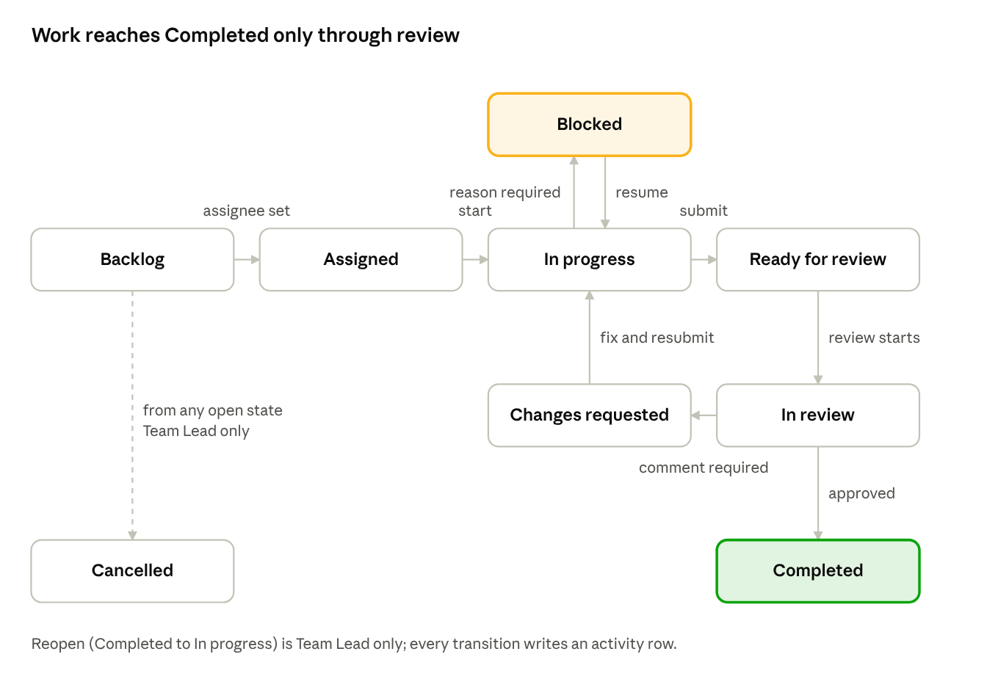
task lifecycle · 9 states
Side effects the server applies on transitions: moving to Blocked sets blocked_at and requires blocked_reason and blocker_type; Completed sets progress = 100 and completed_at; Changes requested requires a comment; any transition updates last_activity_at and notifies the assignee, reviewer and watchers.
Action | Super Admin | Team Lead | Member
Manage users, teams, org settings | Yes | No | No
Create and archive projects | Yes | Own team | No
Create tasks | Yes | Yes | Own subtasks only
Assign, reassign (with handover note) | Yes | Own team | No
Change priority and due date | Yes | Own team | Request only (comment)
Start, block, resume, submit for review | Yes | Yes | Own tasks
Move to In review, approve, request changes | Yes | Yes | Only when set as reviewer
Cancel or reopen a task | Yes | Own team | No
Update progress, log time, checklist, comment, upload | Yes | Yes | Own and watched tasks
View team dashboard, workload, reports | Yes | Own team | Own stats only
Delete comments or attachments | Yes | Own team | Own, within 15 minutes
Enforce these in one RBAC middleware plus a per-task authorize(actor, action, task) check in the service layer; never trust role or team data sent by the client.

Metric definitions
Write these definitions down before building the dashboard; vague metrics are the main reason team dashboards lose trust. "Open" means any status except Completed and Cancelled; "today" is computed in the org time zone.
Metric | Exact rule
Active | Open and status is not Backlog
Due today | Open and due_date = today
Due tomorrow alert | Open and due_date = next working day; sent once at 17:00
Overdue | Open and due_date < today; "days overdue" counts working days only
Blocked | Status = Blocked; show hours since blocked_at
Waiting review | Status in Ready for review, In review; show age since submitted
Completed this week | completed_at within the current week (week start set in org settings)
No update | Status In progress and last_activity_at older than N working hours (default 24)
Average completion time | Median of completed_at − first In progress time, last 30 days (median, not mean, so one outlier doesn't skew it)
On-time rate | Completed tasks with completed_at ≤ end of due_date ÷ completed tasks with a due date, last 30 days
Estimate accuracy | Sum of logged minutes ÷ sum of estimated minutes, completed tasks, last 30 days
Workload uses hours, not task counts:
\text{Load \%} = \frac{\sum_{\text{open tasks due in next 5 working days}} \text{estimated\_minutes} \times (1 - \text{progress}/100)}{(\text{working days available} - \text{leave days}) \times \text{work hours per day} \times 60} \times 100
Show the bar plus the task count, and colour only above 100% (over capacity). Tasks without an estimate count as a default (e.g. 4 hours) and are flagged "unestimated" so the number stays honest.

Phased roadmap
Ship a usable V1 to your team after Phase 2 (about 8 weeks for one developer using an AI coding tool), then add features based on how people actually use it. Durations are rough estimates.
- Phase 0: Foundation (week 1). Monorepo, Docker Compose Postgres, lint, CI, CLAUDE.md. Prompts 1–2.
  - Exit when: pnpm dev runs web + api, CI passes on an empty test.
- Phase 1: Core tasks (weeks 2–5). Schema, auth, RBAC, users/teams/projects, tasks with workflow and activity log, comments, attachments, task list and detail, My Tasks. Prompts 3–9.
  - Exit when: you can create, assign and complete a task through review, and the timeline shows every step.
- Phase 2: Team Lead visibility (weeks 6–8). Dashboard, member page, Kanban, calendar, in-app + email notifications, alert jobs, daily digest, escalations. Prompts 10–13.
  - Exit when: the 09:00 digest matches the dashboard, and alerts are never sent twice. Roll out to the team here.
- Phase 3: Productivity (weeks 9–12). Workload with leave, checklists, time tracking, dependencies, recurring tasks, check-ins, search, saved views, templates, reports and export. Prompts 14–18.
  - Exit when: workload % matches a hand calculation for two members, and a weekly recurring task generates itself.
- Phase 4: Integrations and mobile (weeks 13–15). Git (GitHub/GitLab) webhooks, WhatsApp/Slack/Teams alerts, PWA and web push. Prompt 19.
- Phase 5: Hardening and deploy (runs alongside, finish in week 16). Tests, security review, Docker production build, Nginx, backups, monitoring. Prompts 20–21.
- V2: AI layer (after 2–3 months of real data). Natural-language task creation, AI digest, meeting notes to tasks, risk detection that cites its evidence. Prompt 22.

Build prompts
Run these in order in Claude Code (or Cursor), one prompt per session. Save Prompt 1 as CLAUDE.md first so every later prompt inherits the rules. After each prompt: run the app, read the diff, commit. Where a prompt says [paste …], paste that section of this doc.

Prompt 1: CLAUDE.md (save as a file, not a chat message)
# Team Task Manager: project rules
## Product
Internal task management system for a software team. Roles: SUPER_ADMIN, TEAM_LEAD, MEMBER.
Team Leads create, assign and review tasks and need an accurate real-time view of team status.
Members update their own tasks. The system shows facts and evidence; it never computes a
"performance score" or ranks people.
## Stack
- pnpm workspaces: apps/api, apps/web, packages/shared
- API: Node LTS, Express, TypeScript strict, Drizzle ORM + drizzle-kit, PostgreSQL 16,
pg-boss, Socket.IO, pino, Zod
- Web: React, Vite, TypeScript strict, React Router, TanStack Query, TanStack Table,
Tailwind, shadcn/ui, React Hook Form, dnd-kit, Recharts
- Tests: Vitest, Supertest, Testcontainers (real Postgres), Playwright
## Rules
1. Validate every body, param and query with Zod schemas from packages/shared. Web forms use the same schemas.
2. Enums (status, priority, role, blocker type) and the workflow transition table live in packages/shared only.
3. Every task mutation writes task_activity row(s) and updates tasks.last_activity_at in the SAME transaction.
4. Status changes go only through the workflow service (canTransition). No endpoint sets status directly.
5. Auth: authenticate middleware + authorize(actor, action, resource) in services. Never trust role or team from the client.
6. Store timestamps as timestamptz (UTC). Business dates (today, overdue, working days) use
org_settings.timezone, weekend days and holidays via one date-utils module.
7. REST under /api/v1. Cursor pagination (?cursor=&limit=). Errors: { error: { code, message, details } } with correct HTTP status.
8. Soft delete tasks and comments (deleted_at); exclude them by default.
9. API layout: modules/<domain>/{routes.ts, service.ts, repo.ts, *.test.ts}. Routes are thin; logic in services.
10. Web: data access only through TanStack Query hooks in features/<feature>/api.ts; keys in lib/queryKeys.ts.
11. Every endpoint gets an integration test; every workflow and date rule gets unit tests.
12. Config from env parsed with Zod in config/env.ts; keep .env.example current. No secrets in code.
13. Small functions, plain names, no speculative abstractions. Ask before adding a dependency not listed here.
14. When done: run typecheck, lint, tests; report what changed and what is left.
## Glossary
Task key = project key + number (ERP-125). Open = status not COMPLETED or CANCELLED.
Working day = not a weekend day and not a holiday per org_settings.

Prompt 2: Scaffold the monorepo
Read CLAUDE.md. Scaffold the project:
- pnpm workspace with apps/api, apps/web, packages/shared; base tsconfig (strict), path alias @shared.
- ESLint + Prettier shared config; Husky + lint-staged pre-commit.
- docker-compose.yml for local dev: postgres:16 (named volume, healthcheck), mailpit (email), minio (files).
- apps/api: Express with helmet, cors (credentials, origin from env), cookie-parser, pino-http,
central error handler, config/env.ts with Zod, db client (pg Pool + Drizzle), withTransaction helper,
GET /api/v1/health that checks the DB. Separate entry points: src/server.ts and src/worker.ts.
- apps/web: Vite React TS, Tailwind, shadcn/ui init, React Router, QueryClientProvider,
a placeholder page that calls /health and shows API + DB status.
- packages/shared: enums (role, task status, priority, blocker type) exported as Zod enums + TS types.
- Root scripts: dev (api + web together), build, typecheck, lint, test, db:generate, db:migrate, db:seed.
- GitHub Actions: install, typecheck, lint, test on every pull request.
- README with setup steps.
Done when: docker compose up -d && pnpm i && pnpm dev shows "API ok, DB ok" in the browser.

Prompt 3: Database schema, migrations, seed
Read CLAUDE.md. Implement the database from this schema:
[paste the "PostgreSQL schema" section]
- Drizzle schema files in apps/api/src/db/schema/, one per area, matching the schema exactly:
Postgres enums, FKs with deliberate ON DELETE (RESTRICT for users, CASCADE for task children),
CHECK constraints, partial indexes, the generated tsvector column and its GIN index, citext extension.
- Generate the first migration with drizzle-kit and review the SQL before committing.
- Add a task_links table now too (id, task_id, provider, url, title, created_at) for later Git links.
- Seed script (idempotent): org_settings (timezone from SEED_TIMEZONE env, weekend days, 8 work hours,
no-update threshold 24, digest 09:00); users: 1 super admin, team lead "Sulthan", members Rahul, Arun,
Faisal, Akhil; one team; projects ERP and CRM; ~40 tasks spread over every status, some overdue,
due today, blocked with reasons, in review; matching task_activity rows and a few comments.
- Tests: task number uniqueness per project, progress CHECK, dependency self-reference CHECK.
Done when: a fresh DB migrates and seeds with one command and tests pass.

Prompt 4: Authentication
Read CLAUDE.md. Build authentication in apps/api/src/modules/auth:
- POST /auth/login: argon2id verify; returns a JWT access token (15 min) in the body and sets a
refresh token cookie (httpOnly, secure in production, sameSite=lax, path=/api/v1/auth, 7 days).
Store only a hash of the refresh token in sessions.
- POST /auth/refresh: rotate the refresh token; if a revoked token is reused, revoke all of that
user's sessions. Require a custom header (X-Requested-With) as CSRF defence.
- POST /auth/logout, GET /auth/me (user, role, team ids).
- Password reset: POST /auth/forgot and /auth/reset with a one-time hashed token emailed via SMTP (mailpit locally).
- Rate limit login and forgot (5 per minute per IP + email). Same error message for wrong email or password.
- authenticate middleware sets req.user = { id, role, teamIds }. Inactive users are rejected.
- Admin: POST /users (creates user, emails a set-password link), PATCH /users/:id,
POST /users/:id/deactivate (also revokes sessions).
- Tests for login, refresh rotation, reuse detection, logout, deactivated user.

Prompt 5: Permissions, teams, projects
Read CLAUDE.md. Implement authorization and org structure:
- modules/permissions: authorize(actor, action, resource) implementing this matrix exactly:
[paste the permissions table from "Task lifecycle and permissions"]
Throw a ForbiddenError mapped to HTTP 403. Unit test every row for every role.
- Teams: CRUD (super admin), add/remove members, set lead.
- Projects: create (super admin, or team lead for own team), update, archive. Key must match
^[A-Z]{2,10}$ and is immutable after creation.
- GET /users with filters (teamId, active, q) for pickers; members only see users in their teams.
- Integration tests: a member cannot read or change another team's project.

Prompt 6: Tasks API, workflow, activity log
Read CLAUDE.md. Build the tasks module, the core of the system.
Workflow (packages/shared/src/workflow.ts):
- Transition table and canTransition(from, to, ctx) where ctx = { role, isAssignee, isReviewer, isTeamLeadOfProject }.
Returns { ok, reason?, requires?: ('comment' | 'blockedReason')[] }.
- Rules: [paste the lifecycle section, including side effects]
Endpoints:
- POST /projects/:projectId/tasks: allocate number via UPDATE projects SET task_counter = task_counter + 1
RETURNING, inside the transaction. Status = ASSIGNED if assignee given, else BACKLOG.
- GET /tasks: filters project, assignee, reviewer, status[], priority[], label, dueFrom, dueTo,
overdue=true, blocked=true, parentId, q; sort; cursor pagination. Returns key (ERP-125) on each task.
- GET /tasks/:idOrKey (accepts uuid or ERP-125), with labels, subtask counts, dependencies.
- PATCH /tasks/:id for editable fields only (never status or assignee).
- POST /tasks/:id/transition { to, comment?, blockedReason?, blockerType? }.
- POST /tasks/:id/assign { assigneeId, reviewerId?, handoverNote? } (handover note required when reassigning).
- PUT /tasks/:id/progress { progress }.
- DELETE /tasks/:id (soft delete, lead only).
- GET /tasks/:id/timeline: activity rows and comments merged, newest last.
For every change: one task_activity row per changed field (old/new as JSON), update last_activity_at,
all in one transaction. After commit, emit in-process domain events (task.created, task.updated,
task.transitioned, task.assigned, task.progress) through a typed EventEmitter for later modules.
Tests: the full happy path Backlog to Completed, every forbidden transition per role, required
fields for Blocked and Changes requested, concurrent creates get distinct numbers, timeline order.

Prompt 7: Comments, mentions, watchers, attachments
Read CLAUDE.md. Add collaboration to tasks:
- Comments: create, edit (own, sets edited_at), soft delete (own within 15 min, lead any), list.
Mentions use the token format @[Display Name](userId); parse on save into comment_mentions.
Commenting updates last_activity_at and writes activity.
- Watchers: creator, assignee and reviewer are added automatically; POST/DELETE /tasks/:id/watchers/me.
- Attachments: a StorageAdapter interface with LocalDiskAdapter and S3Adapter (@aws-sdk/client-s3,
works with MinIO). Upload with multer, 25 MB limit, mime allowlist (images, pdf, office docs,
zip, txt, csv). Download through short-lived presigned URLs or a streaming route with auth.
Deleting removes the object and writes activity.
- Emit events comment.created (with mentioned user ids) and attachment.created.
- Tests including a member trying to comment on a task outside their team.

Prompt 8: Frontend shell
Read CLAUDE.md. Build the web app shell in apps/web:
- Auth: login, forgot and reset password pages. Access token held in memory only; an API client
(lib/api.ts) that refreshes once on 401 (single in-flight refresh shared by concurrent requests)
and redirects to login when refresh fails. Restore session on page load via /auth/refresh.
- Route guards by role. Layout with sidebar: Dashboard (lead/admin), My Tasks, Tasks, Board, Calendar,
Team, Workload (lead), Reports (lead), Settings. Top bar: search box placeholder, notification bell
placeholder, user menu, light/dark toggle.
- lib/queryKeys.ts, features/<name>/api.ts pattern, shared Zod types for all responses.
- Common components: DataTable wrapper, UserAvatar, PriorityBadge, StatusBadge, DueBadge
(red when overdue, amber when due today), ProgressBar, EmptyState, skeleton loaders, toasts,
error boundary, confirm dialog.
- Responsive down to 375 px wide; keyboard accessible.

Prompt 9: Task list, task detail with timeline, My Tasks
Read CLAUDE.md. Build the task screens:
- /tasks: TanStack Table with columns Key, Title, Assignee, Priority, Status, Progress, Due, Last update.
Filter bar (project, assignee, status multi-select, priority, label, due range, overdue, blocked)
synced to the URL. Sorting, infinite scroll with cursor pagination.
- Create task drawer: title, description (markdown editor with preview), project, assignee picker,
reviewer, priority, due date, estimated hours, labels (create inline), dependencies (search by key),
attachments. Zod schema from packages/shared.
- /tasks/:key detail page: key + inline-editable title; status action buttons rendered ONLY from
canTransition for the current user, with dialogs for required input (block reason + type,
changes-requested comment); progress slider; right-side fields panel; description; attachments;
Timeline that renders activity as sentences ("Rahul changed progress 20% to 45%",
"Sulthan assigned to Rahul") interleaved with comments; comment box with @mention autocomplete;
watch/unwatch button.
- /my-tasks for members: groups Overdue, Due today, This week, Later, Waiting for review, with quick
actions (start, update progress, submit for review).
- Optimistic updates with rollback on error; invalidate the timeline after every mutation.

Prompt 10: Team Lead dashboard and member page
Read CLAUDE.md. Build the dashboard using these exact definitions:
[paste the "Metric definitions" table]
API (modules/dashboard):
- GET /dashboard/summary?teamId=: all KPI counts in ONE SQL query using COUNT(*) FILTER (WHERE ...).
- GET /dashboard/members?teamId=: per member active, overdue, blocked, waiting review,
completed this week, last activity time.
- GET /dashboard/attention?teamId=: ordered list with a reason per item: overdue (most working days
first), due today with progress < 50, blocked longest, no update, review waiting > 24 working hours.
- Pass "now" in as a parameter so tests can fix the clock.
Web:
- /dashboard: KPI cards (each links to the task list pre-filtered), member table (links to member page),
"Needs your attention" list with reason chips.
- /team/:userId: current work cards (priority colour, due, progress, status), stats (active, overdue,
blocked, completed last 30 days, median completion time, on-time rate), recent activity.
Members can open their own page and see exactly the same data.
- Tests: a seeded fixture where every KPI has a known expected value, including weekend and time zone edges.

Prompt 11: Kanban board and calendar, live updates
Read CLAUDE.md. Add two more task views and realtime:
- /board: one column per status (Backlog and Cancelled hidden behind a toggle), dnd-kit drag and drop.
On drop call /transition; if canTransition says no, snap back and toast the reason; if input is
required, open the dialog before sending. Optional swimlanes by assignee. Column counts.
Card: key, title, assignee avatar, priority, due badge, progress bar, blocked icon.
- /calendar: month and week views by due date (bars from start_date to due_date when both exist),
colour by priority, filters by member and project; team leads can drag to change due date.
- Realtime: Socket.IO server authenticates the access token on handshake; rooms user:<id> and
project:<id>. Broadcast task events from the domain event bus. Web subscribes per open project
and patches the TanStack Query cache so the board updates live without a refetch storm.

Prompt 12: Notifications
Read CLAUDE.md. Build notifications (modules/notifications):
- Subscribe to domain events. Rules: assigned -> assignee; mentioned -> that user; status changed ->
assignee, reviewer and watchers except the actor; submitted for review -> reviewer, else team lead;
changes requested -> assignee; new comment -> watchers except author; dependency completed ->
assignee of the dependent task.
- Always store in-app notifications; emit notification:new to room user:<id>.
- Email is sent by a pg-boss job, never inside the request. Respect notification_preferences
(per type: in-app, email, digest only) and quiet hours (default 20:00-08:00 user local time;
held emails go out at 08:00).
- Collapse bursts: several updates on one task within 5 minutes become one email.
- Web: bell with unread count, dropdown list, mark read / mark all read, /notifications page,
preferences page in Settings.
- Email templates with React Email; verify in mailpit.

Prompt 13: Alerts, daily digest, escalations
Read CLAUDE.md. Build scheduled jobs in apps/api/src/jobs using pg-boss, all times in org time zone:
- Every 30 minutes: OVERDUE, NO_UPDATE, BLOCKED (over threshold), REVIEW_WAITING (> 24 working hours).
- 17:00 on working days: DUE_TOMORROW (next working day).
- Escalation: overdue >= 2 working days or blocked > 24 working hours -> notify team lead again,
marked as escalation.
- De-duplicate with alert_log: at most one alert per task per type per day.
- Daily digest at org_settings.digest_time on working days:
* Team lead: team counts, "Needs your attention" top 10 (reuse the dashboard service),
completed yesterday, members on leave today.
* Member: your overdue, due today, reviews waiting on you.
In-app + email; format like the "GOOD MORNING" example in the original plan.
- Admin endpoint and Settings button to preview a digest for any date.
- Tests with a fake clock: Friday -> Monday, holidays, midnight in the org time zone, no duplicate alerts.

Prompt 14: Workload, leave and holidays
Read CLAUDE.md. Add capacity-aware workload:
- Leaves CRUD (members manage their own; leads see their team), holidays and org settings admin pages.
- date-utils: isWorkingDay, workingDaysBetween, addWorkingDays, all time-zone aware, fully unit tested.
- GET /workload?teamId=&days=5 using this formula:
[paste the workload formula and notes from "Metric definitions"]
Return per member: load %, open task count, unestimated count, leave days in the window.
- /workload page: horizontal bars per member, highlight only above 100%, "on leave" badges,
click a member to see the tasks making up their load.
- Assignee picker everywhere shows each member's load % and leave status.
- Reassign flow: handover note required, previous assignee stays as watcher, activity recorded.

Prompt 15: Checklists, time tracking, dependencies
Read CLAUDE.md. Add work-detail features, each writing activity rows:
- Checklist items: add, edit, tick, reorder (drag). Per-task option "progress follows checklist"
(progress = done / total, rounded).
- Time tracking: start/stop timer (one running timer per user; starting another stops the first),
manual entries, edit own entries within 7 days. Task shows logged vs estimated. /timesheet page:
my week by day and task. Logging time updates last_activity_at.
- Dependencies: add/remove with cycle detection (recursive CTE). A task with open BLOCKS
dependencies shows "Waiting on ERP-102" and starting it asks for confirmation. When a dependency
completes, notify the dependent task's assignee.
- Tests: cycle detection, single running timer, checklist-driven progress.

Prompt 16: Recurring tasks and templates
Read CLAUDE.md. Add automation:
- Recurring rules stored as RRULE strings (rrule library) in the org time zone. UI builder: daily,
weekly on chosen days, monthly on day N, custom; option "skip holidays, move to next working day".
- pg-boss job every 15 minutes creates tasks whose occurrence is due. Idempotent: add an occurrence
date to generated tasks with a unique (recurring_rule_id, occurrence_date) constraint. Sets due date
and time from the template, assigns, notifies.
- Task templates: save any task (with checklist) as a template; create from template.
- Project templates: a named set of tasks with relative due dates (day 0, +2 working days...)
applied to a project in one click.
- Tests: weekly Monday 10:00 rule over a holiday week, no duplicates when the job runs twice.

Prompt 17: Daily check-ins
Read CLAUDE.md. Add async stand-ups:
- /check-in form: yesterday, today, blockers. Prefill "today" with my In progress tasks as links.
One per user per working day, editable the same day.
- Reminder notification at 10:00 on working days to members who have not checked in and are not on leave.
- Lead view /check-ins?date=: every member's entry, blockers highlighted, missing check-ins listed,
and a button to mark a linked task Blocked straight from a blocker line.
- Dashboard panel: "Check-ins today: 6 of 8, 2 blockers".

Prompt 18: Search, saved views, bulk actions, reports
Read CLAUDE.md. Add power-user and reporting features:
- GET /search?q=: exact task key match first, then Postgres full-text over tasks and comments
(add a generated tsvector to task_comments), scoped to what the user may see.
- Ctrl+K command palette (cmdk): jump to task, project, member; actions like "Create task",
"Go to board".
- Saved views: save the current filters + view type (table/board/calendar), personal or shared with team.
- Bulk actions in the table: reassign (handover note), priority, due date, labels, cancel. Each task
gets its own activity rows; one summary notification per affected user.
- /reports (leads): throughput per week, overdue trend, on-time rate, median cycle time, estimate
accuracy by member and by label, total blocked hours by blocker type. Filters: date range, team,
project. Charts with Recharts. Export CSV and XLSX (exceljs).
- Reports show facts per metric only: no composite scores, no rankings.

Prompt 19: Integrations and mobile
Read CLAUDE.md. Add integrations behind feature flags in org settings:
- Git: webhook endpoints for GitHub and GitLab with signature verification. Find task keys (ERP-125)
in branch names, commit messages and PR titles; save to task_links and show on the task.
PR opened -> move to READY_FOR_REVIEW if canTransition allows; PR merged -> comment on the task and
notify the reviewer. Never auto-complete.
- Chat: a ChannelAdapter interface. Implement Slack and Microsoft Teams incoming webhooks for the
team digest and escalations, and WhatsApp Business Cloud API for per-user alerts (explicit opt-in,
phone number + consent stored, approved message templates only).
- PWA: manifest and service worker (vite-plugin-pwa), Web Push with VAPID keys, push subscription
table, respects notification preferences and quiet hours.

Prompt 20: Tests and security hardening
Read CLAUDE.md. Harden the system:
- Playwright end-to-end: lead creates and assigns -> member starts, blocks, resumes, submits ->
lead requests changes -> member resubmits -> lead approves; dashboard counts and timeline update.
- Access tests: for every :id route, prove a member of team A cannot read or change team B's data.
- Security: helmet with a real CSP, strict CORS, body size limits, rate limits on auth and uploads,
parameterised SQL only, file type sniffing on uploads, secure cookie flags, audit log for admin
actions, pnpm audit clean.
- Performance: seed 50,000 tasks, run EXPLAIN ANALYZE on dashboard, task list and search queries;
add indexes where needed; target < 200 ms p95 for dashboard endpoints. Fix any N+1 queries.
- Report findings as a checklist with what was fixed.

Prompt 21: Production deployment
Read CLAUDE.md. Prepare production deployment:
- Multi-stage Dockerfiles: api image (commands for server and worker), web image (build, then served by Nginx).
- docker-compose.prod.yml: nginx, api, worker, postgres (or external DATABASE_URL), minio;
healthchecks and restart policies. Migrations run as a one-off step before api starts.
- Nginx: TLS with Let's Encrypt, gzip, SPA fallback, proxy /api and /socket.io with WebSocket
upgrade headers, client_max_body_size 25m, security headers.
- Backups: nightly pg_dump to S3-compatible storage, 14-day retention, plus a restore script and a
documented monthly restore test. Back up the file bucket too.
- Observability: /health and /ready, pino JSON logs with rotation, optional Sentry for api and web.
- GitHub Actions: on tag, build and push images, deploy over SSH, run migrations, smoke test /health.
- Write docs/deploy.md as a step-by-step runbook, including rollback.

Prompt 22: V2 AI layer (after 2–3 months of real data)
Read CLAUDE.md. Add an AI module behind a feature flag, using the Claude API via the Anthropic SDK
(model name from env). Rules: AI proposes, people confirm; every AI statement cites task keys or
data it used; AI never rates or ranks people.
- Natural language -> task draft: "Fix the invoice calculation bug and test UAE VAT" becomes a
structured draft (title, description, subtasks, priority, suggested due date, suggested assignee
based on workload and labels) validated with Zod and shown as an editable preview. Nothing is
created until the lead clicks Create.
- AI daily summary: turns the digest data, attention list and check-ins into a short paragraph,
each claim linked to its task key.
- Meeting notes -> proposed tasks: paste a transcript, get a list of proposed tasks with owner and
date; the lead accepts, edits or drops each one.
- Risk detection: compute rule-based signals first (no update, open dependency, due soon with low
progress, repeated changes requested, reopened); the AI only writes a short explanation of the
signals and shows them as an evidence list.
- Log every AI request and response for audit, with a per-org monthly usage cap.

